1.93: a) Using Equations (1.21) and (1.27), and recognizing that the vectors 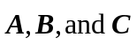do not have the same meanings as they do in those equations,

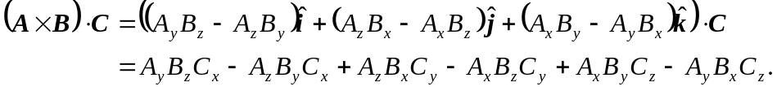
A similar calculation shows that

and a comparison of the expressions shows that they are the same.

b) Although the above expression could be used, the form given allows for ready compuation of 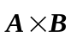 the magnitude is 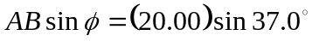and the direction
is, from the right-hand rule, in the +z-direction, and so

